H.T No
Regulations:
A22

Sreenidhi Institute of Science and Technology
(An Autonomous Institution)
Code No:9A304 Date: 03-September-2024 (FN)

B.Tech II-Year I- Semester External Examination, September -2024 (Supplementary)
ELECTRICAL CIRCUITS AND NETWORKS-II (EEE)

Time: 3 Hours Max.Marks:60

Note: a) No additional answer sheets will be provided.
b) All sub-parts of a question must be answered at one place only, otherwise it will not be valued.
c) Missing data can be assumed suitably.
Bloom's Cognitive Levels of Learning (BCLL)

Remember | L1 | Apply | L3 | Evaluate | L5
Understand | L2 | Analyze | L4 | Create | L6

Part - A Max.Marks: 6x2=12

Answer all QUESTIONS, EACH QUESTION CARRIES 2 MARKS.

 |  | BCLL | CO(s) | Marks
1 | Explain the concept of Balanced Load? | L2 | CO1 | [2M]
2 | Calculate the time constant of RC circuit with R=20Ω and C=10µF. | L3 | CO2 | [2M]
3 | Find the DC Gain of the function H(s)=25(s+2)/(s²+5s+5) | L3 | CO3 | [2M]
4 | What is reciprocal network? | L1 | CO4 | [2M]
5 | Explain the function of a band elimination filter? | L2 | CO5 | [2M]
6 | What is fourier analysis? | L1 | CO6 | [2M]

Part – B Max.Marks: 6x8=48
ANSWER ALL QUESTIONS. EACH QUESTION CARRIES 8 MARKS.

 |  | BCLL | CO(s) | Marks
7. | With the help of connection diagram and phasor diagram, show that two watt meters are sufficient to measure active power in a three phase three wire system with balanced star connected load | L3 | CO1 | [8M]
 | OR
8 | Derive the relation between phase voltage and line voltage of a balanced three phase star connected system with the help of phasor diagram. | L5 | CO1 | [8M]
9. | Using Laplace transform determine the current in the circuit shown in the following figure when the switch S is closed at t=0. Assume zero initial condition.  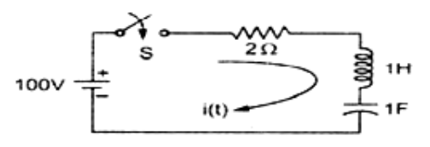 | L5 | CO2 | [8M]
 | OR
10 | Derive the expression for transient response of series R-C circuit driven by sinusoidal excitation? | L5 | CO2 | [8M]
11 | Explain different types network functions as applied to single port and two port network. Obtain Y12 of the given network shown in figure  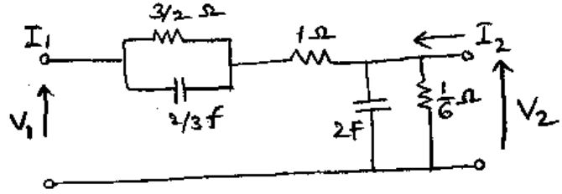 | L2 | CO3 | [8M]
 | OR
12 | Write the necessary conditions for Driving Point Functions and Transfer Function? | L1 | CO3 | [8M]
13 | Find the Y-parameters for the circuit shown in figure  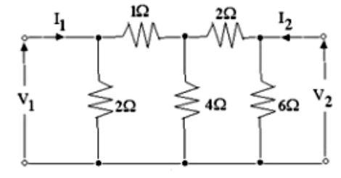 | L1 | CO4 | [8M]
 | OR
14 | Discuss the condition of Symmetry in Z-Parameter and Y-Parameter representation? | L2 | CO4 | [8M]
15 | Design a band pass filter with cutoff frequencies of 2000Hz and 5000Hz with a design impedance of 500 ohms. | L4 | CO5 | [8M]
 | OR
16 | Derive the equations to find the inductances and capacitances of a constant K high pass filter. | L5 | CO5 | [8M]
17 | Explain in brief concept of even and odd functions? | L2 | CO6 | [8M]
 | OR
18 | - List out the Fourier Transform Properties?  - Find the fourier transform of the time function 3e^{-t} cos4t u(t) | L6 | CO6 | [8M]

-- 00 -- 00 –

